**Code: Flex Balls 1**

**Send Feedback**

We have some balls put inside the box ready to export. Currently the balls are arranged as follows -

[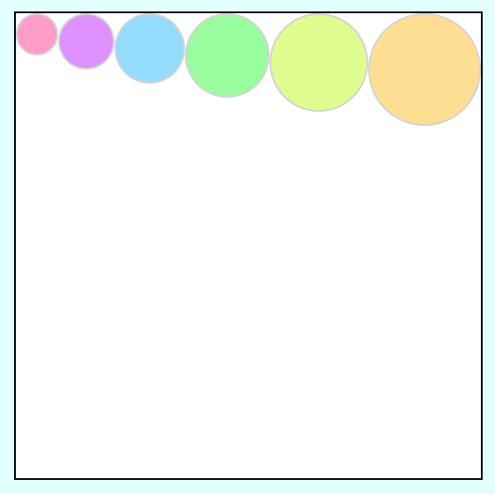](https://ninjasfiles.s3.amazonaws.com/0000000000001665.png)

Before exporting them, some changes to the arrangement of these balls is needed.

First, reverse the order of these balls and it would look like this -

[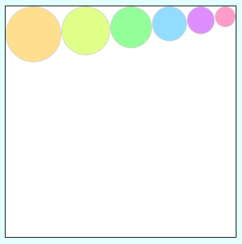](https://ninjasfiles.s3.amazonaws.com/0000000000001665.png)

Now, rotate these balls 90deg in clockwise direction and it would look like this -

[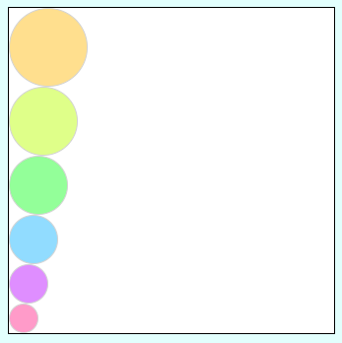](https://ninjasfiles.s3.amazonaws.com/0000000000001664.png)

At last, change their sequence in the following manner -

[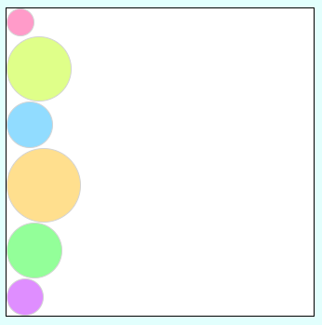](https://ninjasfiles.s3.amazonaws.com/0000000000001672.png)